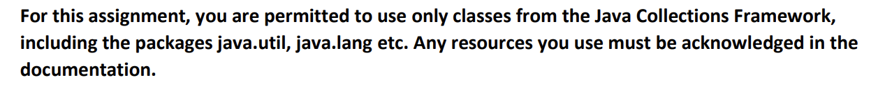

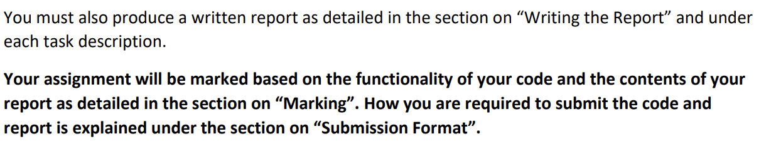

Task 1: Implementing IPhoneme

Task 2: Implementing IPronunciation

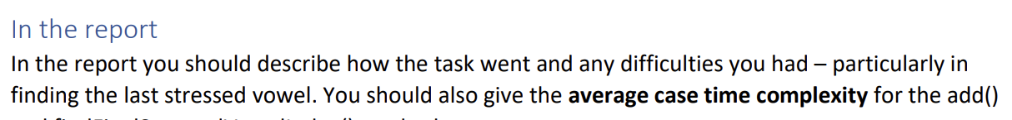

Task 3: Implementing IWord

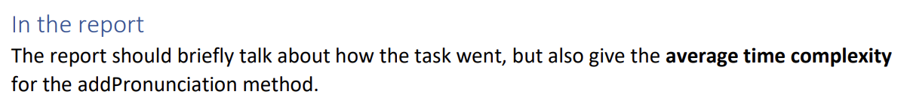

Task 4: Implementing IDictionary and parsing the CMU file

Task 5: Rhyming!

